PC-CENTRE

|  |  |  |
| --- | --- | --- |
| **Supervisor.** | Abdul Wahab | |
| **Batch.** | 2112F1 | |
| **Group.** | B | |
| **Serial No.** | **Enrollment Number** | **Student Name** |
|  | Student1355396 | Muhammad Abrar |
|  | Student1356120 | Tayyab |
|  | Student1351537 | Rafay |
|  | Student1352926 | Muhammad Mubashir |
|  | Student1355418 | Muhammad Hassan Tahir Ali |

# ACKNOWLEDGEMENT

The first, we would like to express my special thanks of gratitude to my teacher ‘Sir Abdul Wahab’, who helped us a lot in finalizing this project within the limited time frame, valuable counselling and assistance for the accomplishment of this project.

Secondly, we would also like to thank the eProject team at Aptech Head Office, who gave us the golden opportunity to do this wonderful project about Aura Watch.

Thirdly, we also thank the eProject team, some of the benefits are as under:

* Re-enforcement of skills happens in the experiential learning process.
* A mentor, ensuring that we do not get drifted, constantly guides us.
* It gives us a lot of confidence to face an interview as we have worked on a project. We can explain virtually everything on the subject we have learnt.

# SYNOPSIS

PC-Centre is a provider of IT products and services in and around the city. With over 2 years experience and a portfolio of over 1,000 products from many leading, manufacturers, they are an independent supplier, offering great deals and best pricing on variety of items, from a massive selection of top brands. Their product range includes hardware, software, peripherals, networking, communications, media, supplies and accessories etc.

In addition, PC-Centre offers home PC installations for consumers and various complementary IT solutions for business including high end enterprise solutions aimed at keeping infrastructures running smoothly.

Post Sales support is the most important aspect of business and they aim to exceed customer’s expectations with a superior level of after-sales technical and customer services. They provide a strong team of qualified Technical Support and Customer Service Advisors to offer advice, assistance and support for any products and solutions purchased from PC-centre.

However, purchases are made directly on the website

# PROBLEM DEFINITION

The PC-centre is very popular in the market and the sale is increasing day by day.

The client visits the shop in order to finalise the deal, but due to the popularity the staff is finding it difficult to handle enquiries and servicing the clients at such a large scale.

The management team hence came out with a solution that the company should have a web site of its own which will host information of the entire business, services provided, products available etc.

So, we solved many particular queries as followed:

* How the sitemap possibly looks alike?
* What information should be displayed on each page?
* How to put every comment is friendly?
* How to give users the best experience when using the website?
* How to let the website properly functioning along with the system requirement?
* Will the user be able to contact with Handicrafts company for advice?

# CUSTOMER REQUIREMENT SPECIFICATION (CRS)

After discussion, we are supposed to create a website for them with the below mentioned requirement specifications:

* + Home page should display the news and offers by various dealers.
  + The home page should have a link to products page. This link should display the available products sorted category wise. There will be a number of categories here, so needs to be very careful while forming the categories and designing, it should be very much user friendly. The products can be broadly categorized into.
  + Displays
  + Motherboards & processors
  + Notebooks
  + Storage
  + Memory
  + Modems
  + Sound
  + Mice / Keyboards
  + Printers
  + Scanners
  + Ups
  + Accessories etc
* The categories above can further lead to sub-categories.
* When user clicks on any of the product category, it will either display a list of products in that category or link to sub-category which in turn will show the products.
* The click on any of the product will lead to a page containing thumbnail images of the products, features and price details.
* Help & FAQs: this page will give the information about locating the technical support centres and most commonly asked queries and answers for these queries.
  + The site should also provide a catalogue of the standard company products like dell, acer, Toshiba etc. This catalogue will contain products only of that particular company, price details and dealers locations.

# SCOPE OF THE WORK (IN BRIEF)

The website is to be developed for the Windows Platform using HTML5, JavaScript, CSS5 and Bootstrap. The site should work well in all leading browsers including Chrome, IE, Firefox etc.

Homepage show Top best sell items, big sale, collection, new shop... Every content direct to relative content.

# AGGREGATED SITEMAP

PC-CENTRE

(0.Welcome.html)

PC-CENTRE (Home)

(1.Index.html)

# SITEMAP

7

PC-CENTRE(Home)

|  |  |  |  |  |
| --- | --- | --- | --- | --- |
| PC-Centre Products  (Dropdown) | About us |  | Contact Information | Gallery |

|  |
| --- |
| *10 Products => Product Details* |
| *10 Products => Product Details* |
| *10 Products => Product Details* |
| *10 Products => Product Details* |
| *10 Products => Product Details* |
| *10 Products => Product Details* |

|  |
| --- |
| HARDWARE  SOFTWARE  LAPTOP  DESKTOP COMPUTER  DISPLAY  KEYBOARD  MOUSE  SOUND  HEAD SET MIC  PRINTERS  SCANNERS  UPS |
|  |
|  |
|  |
|  |
|  |

# WEB DETAILS

1. Home Page (1.Index.html)

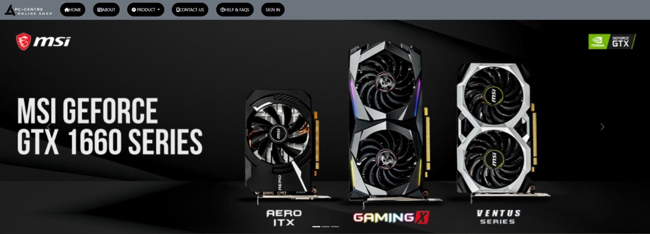

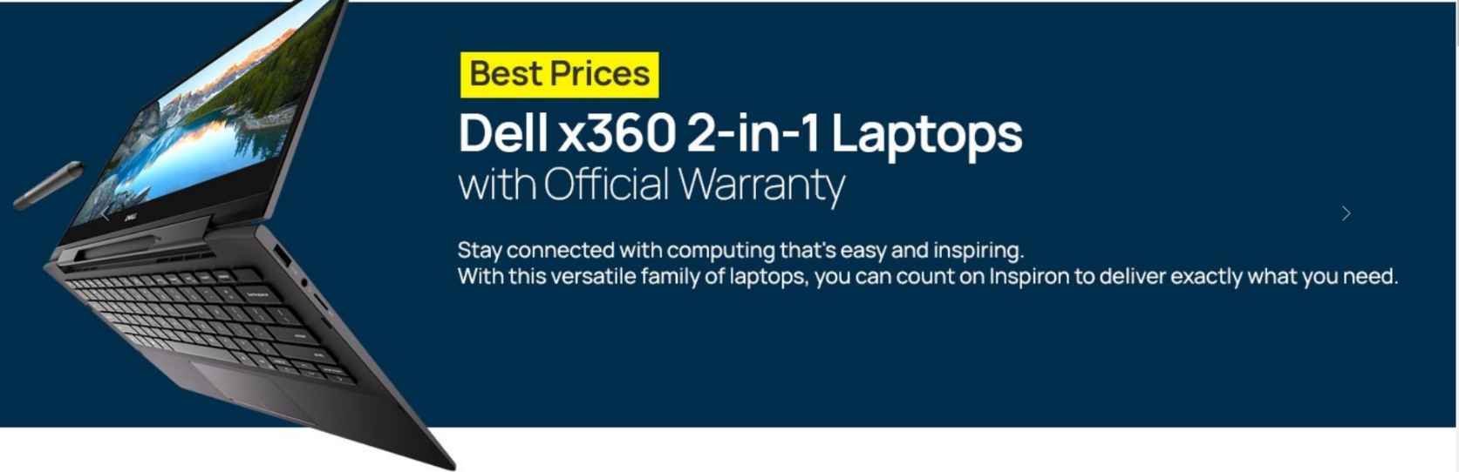

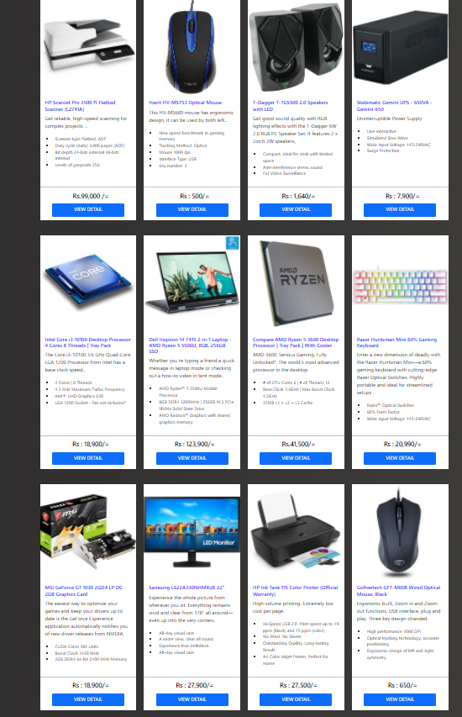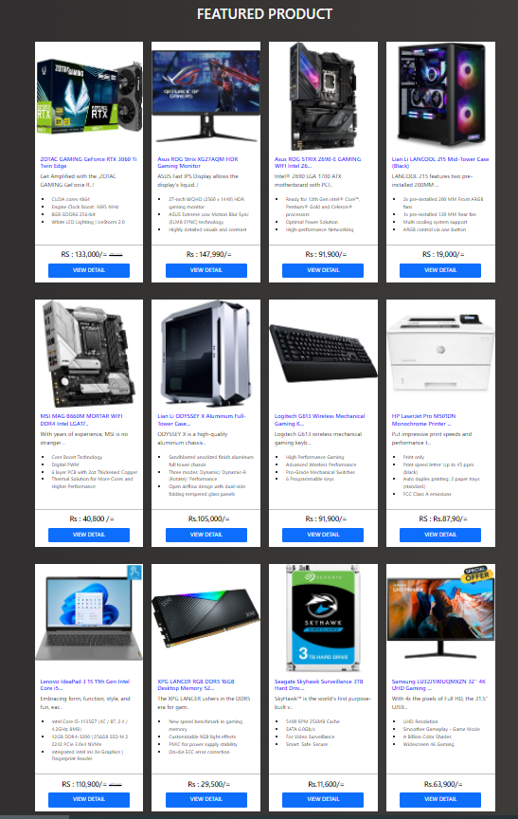

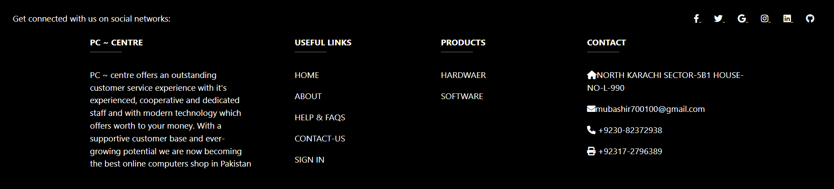

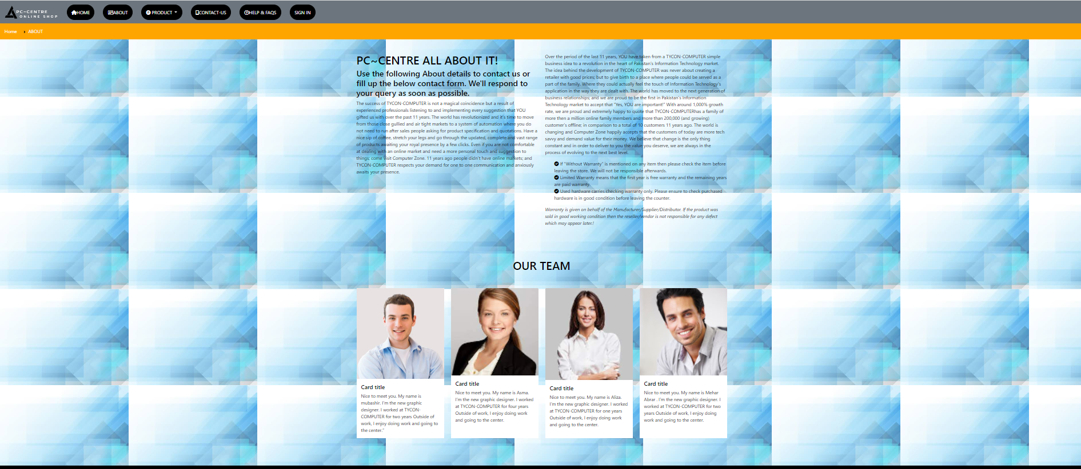

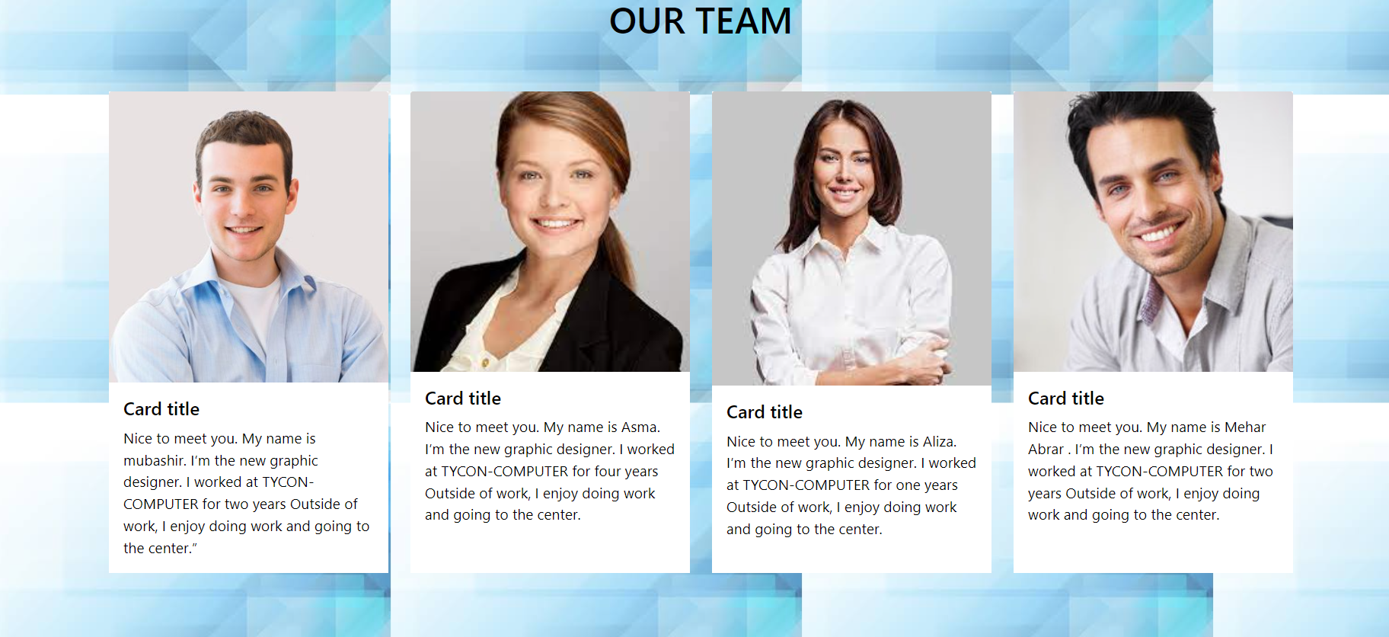

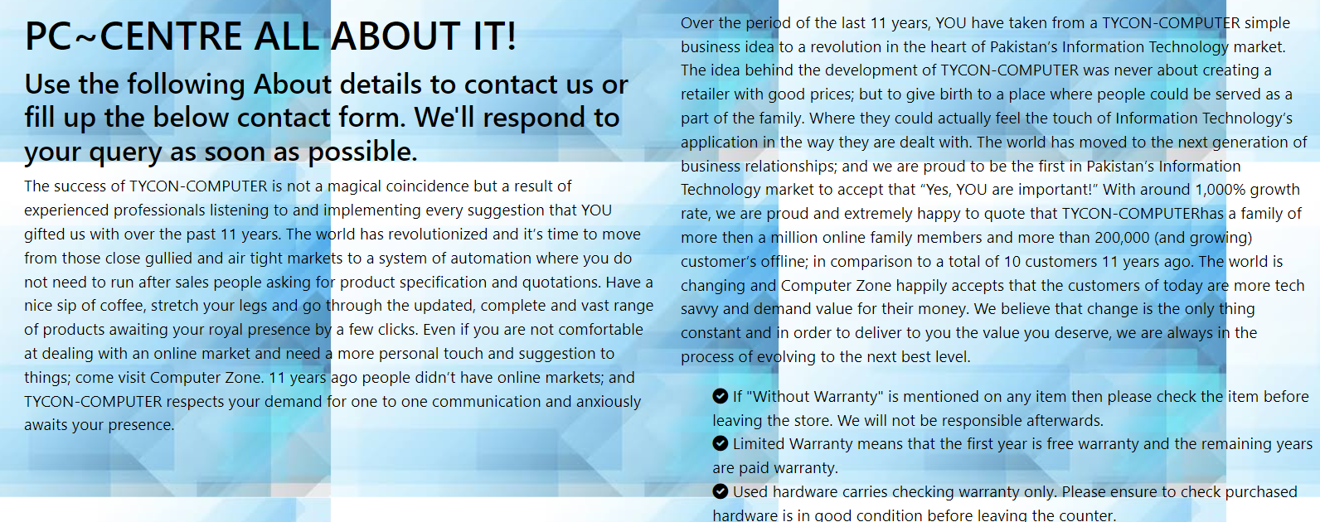

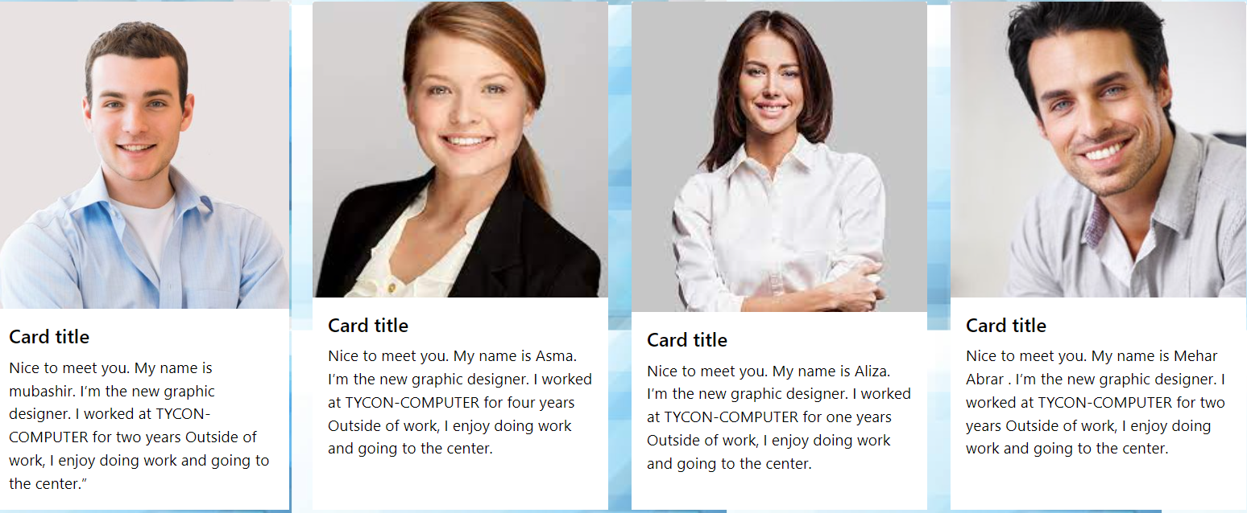

**FOOTER WITH STICKY HEADER**



1. PC-CENTRE Products (Drop down)

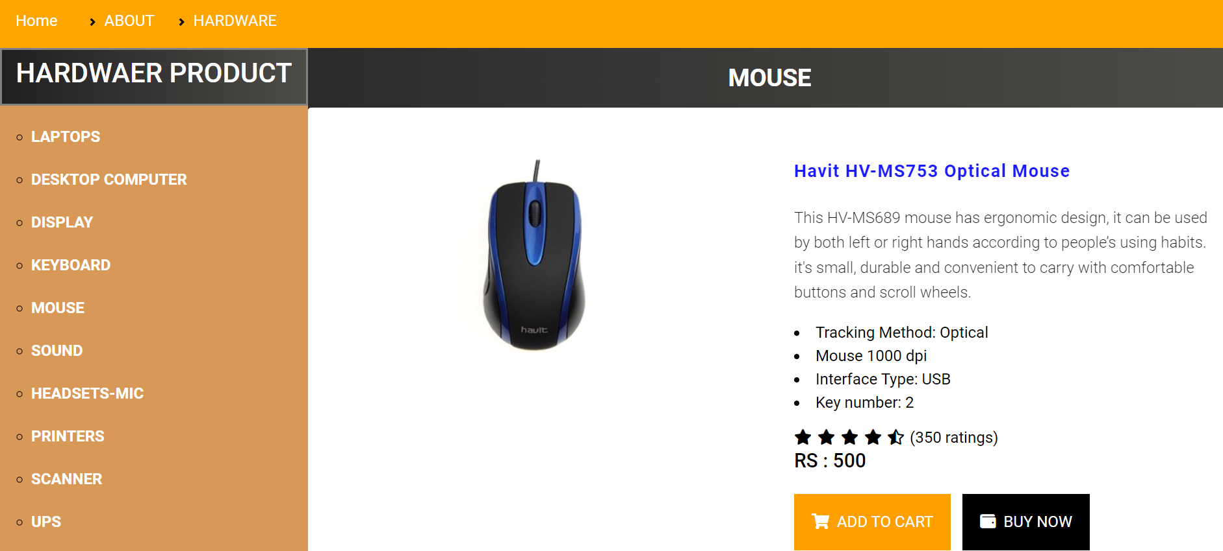

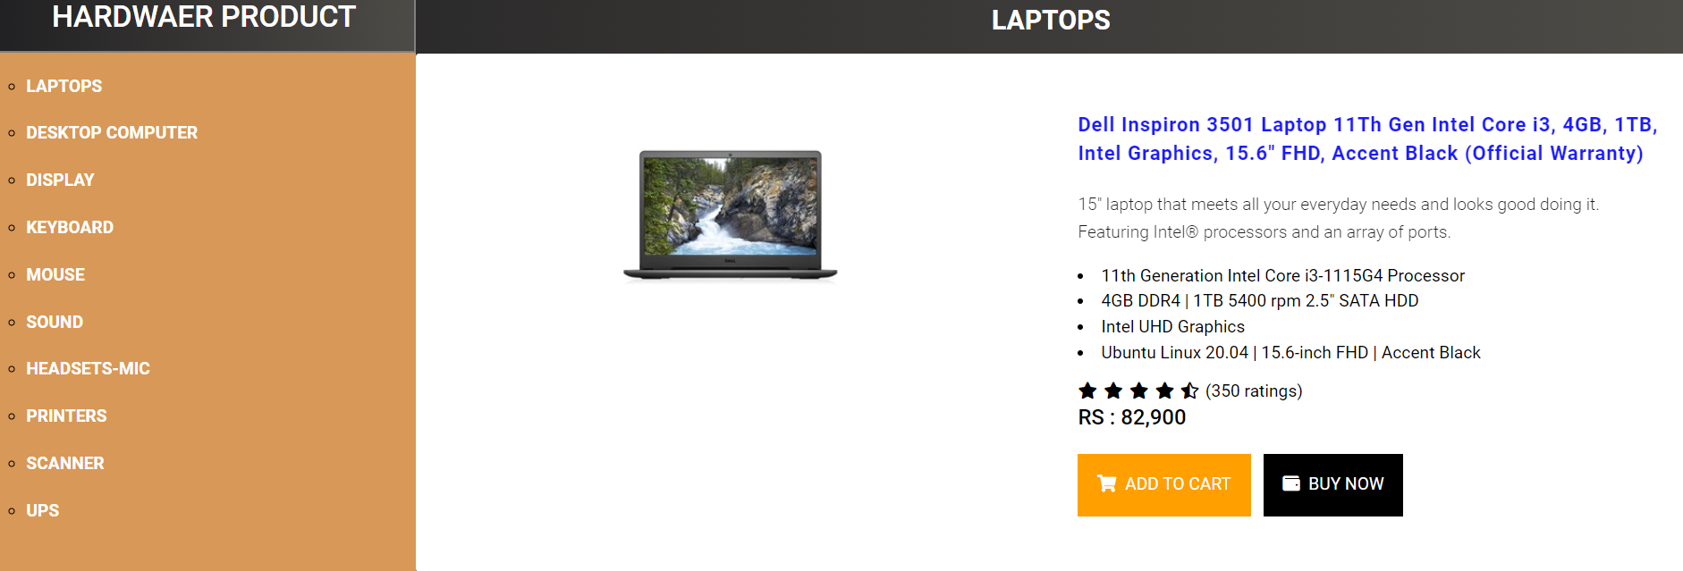

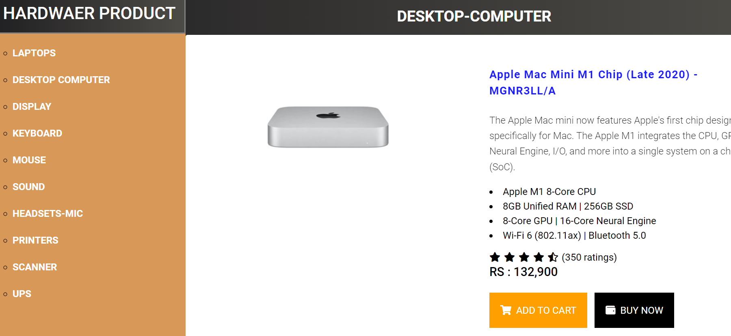

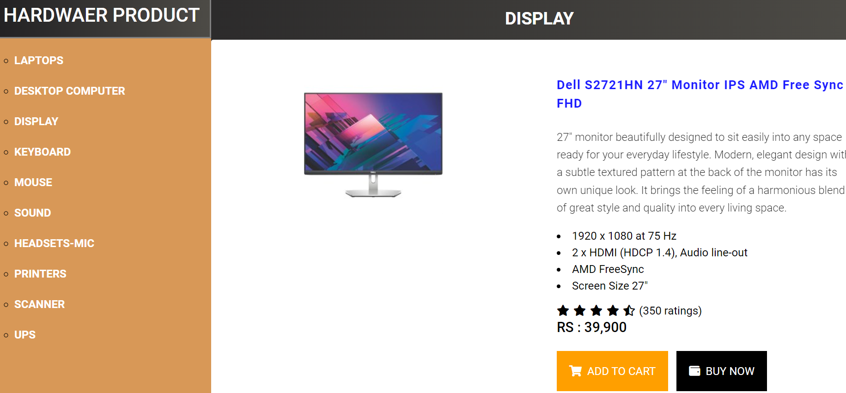

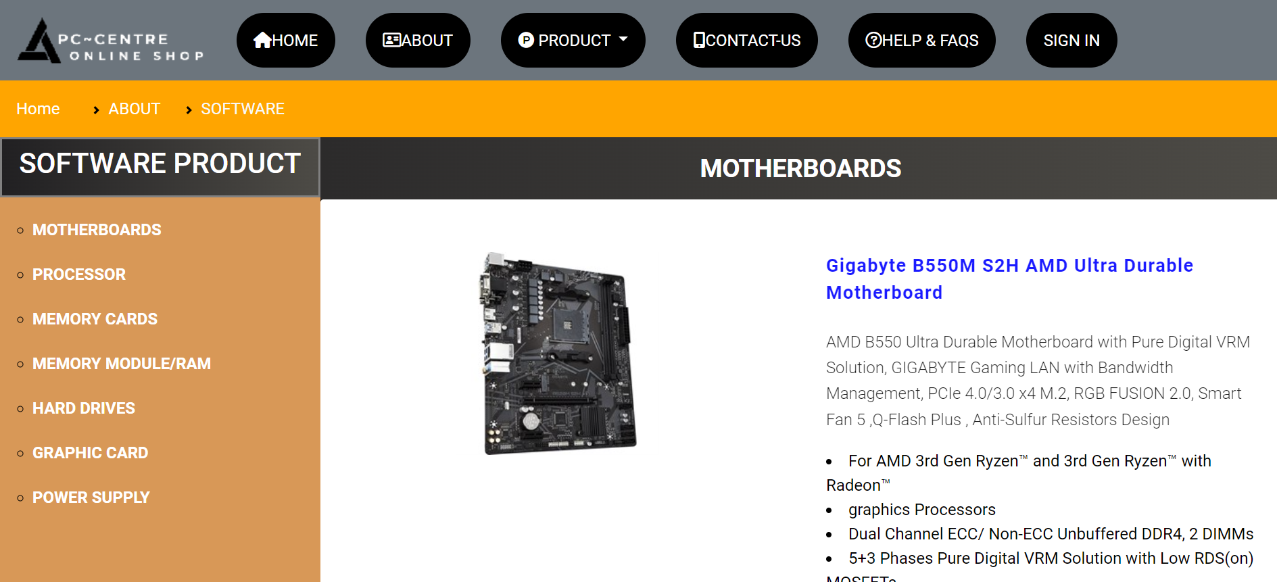

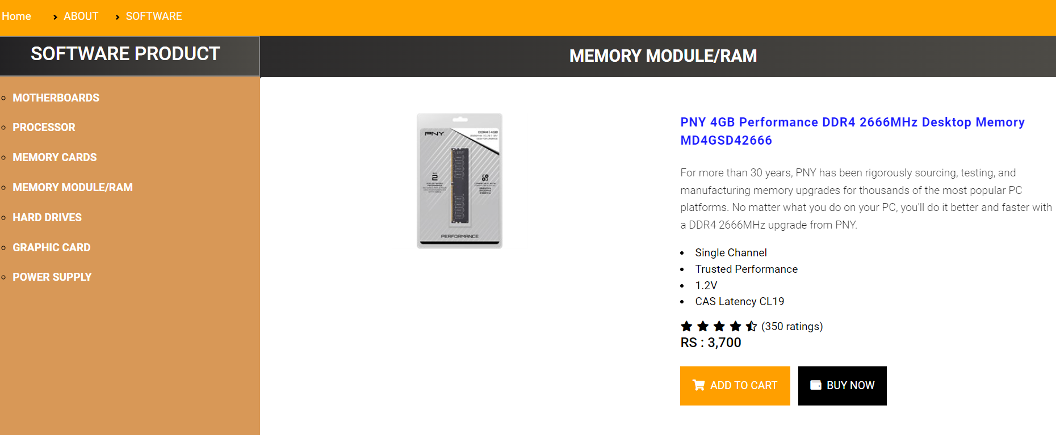

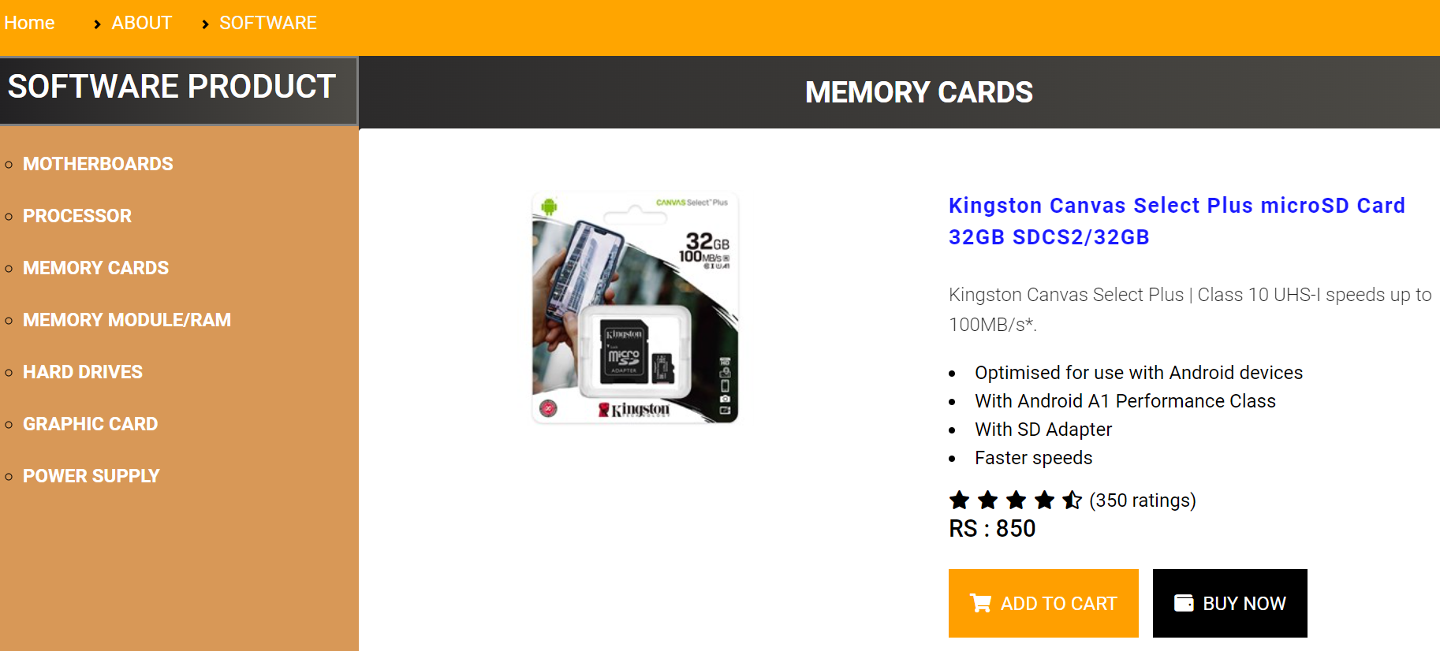

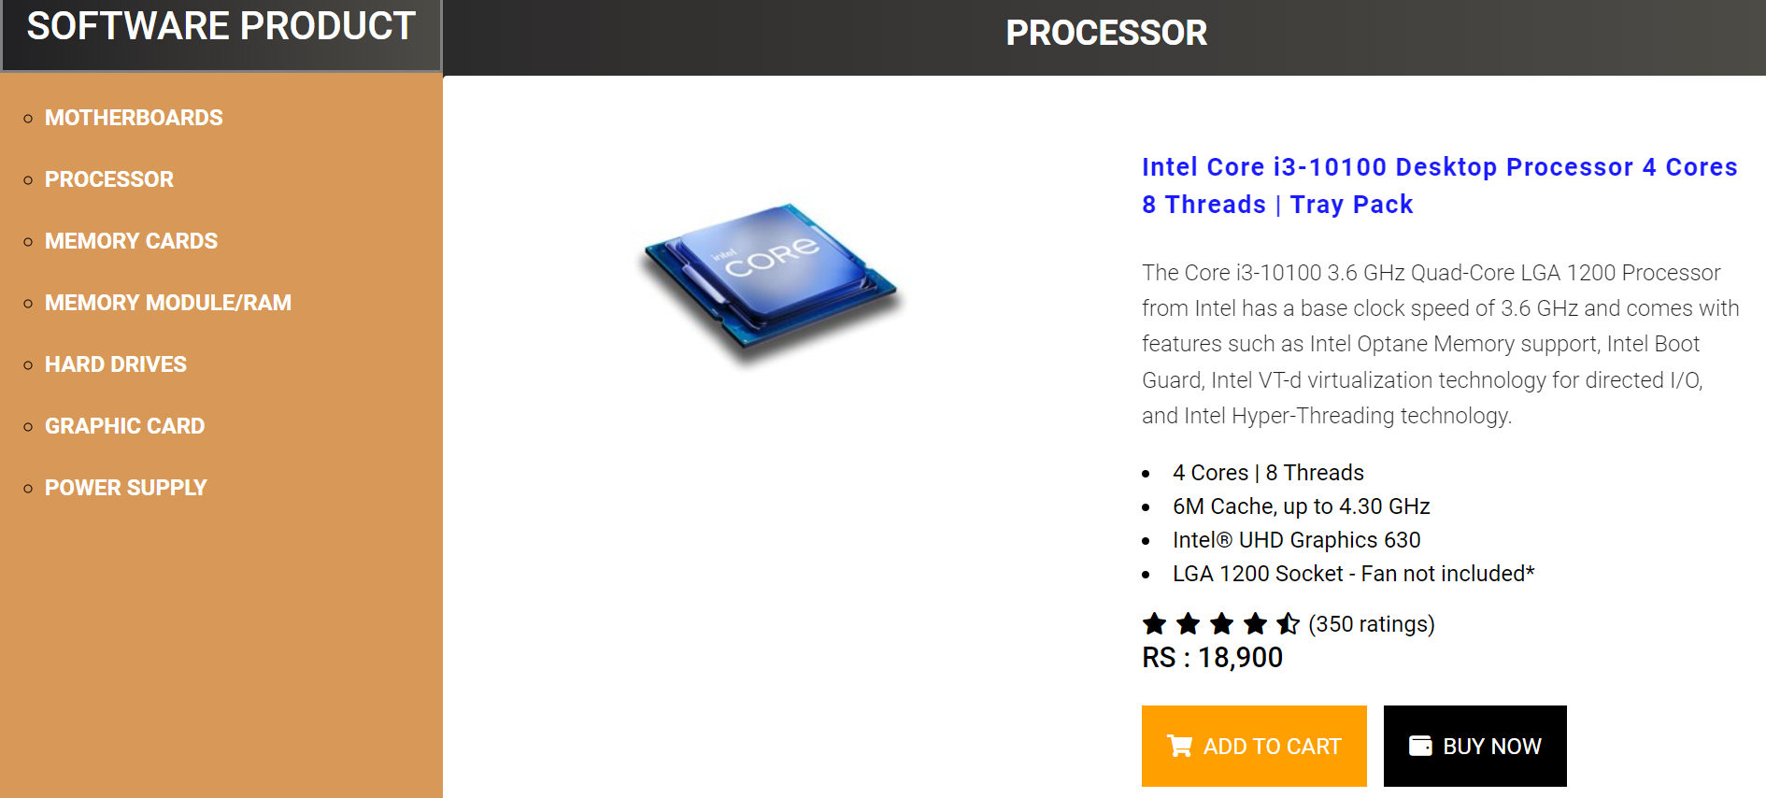

1. (contact us.html)

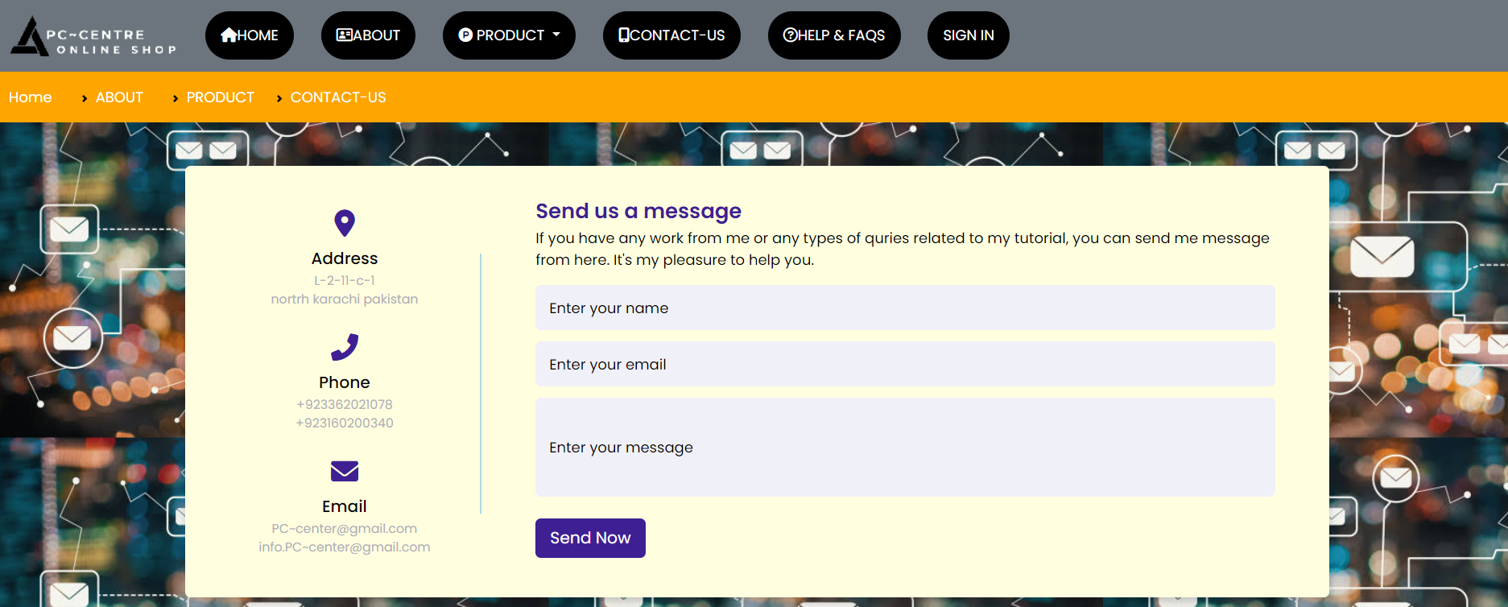

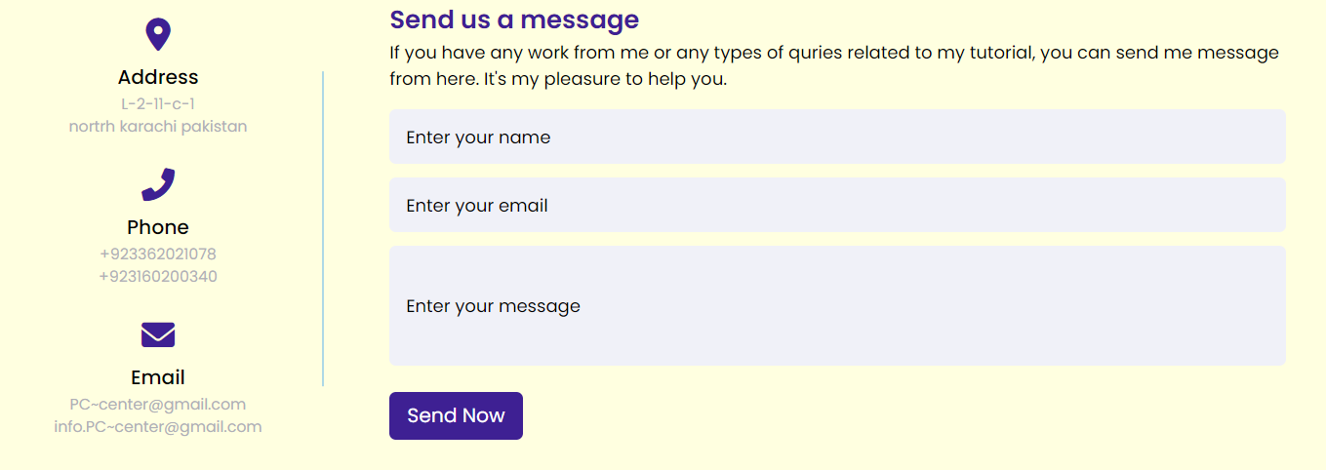



1. (Sign in.html)

ml)

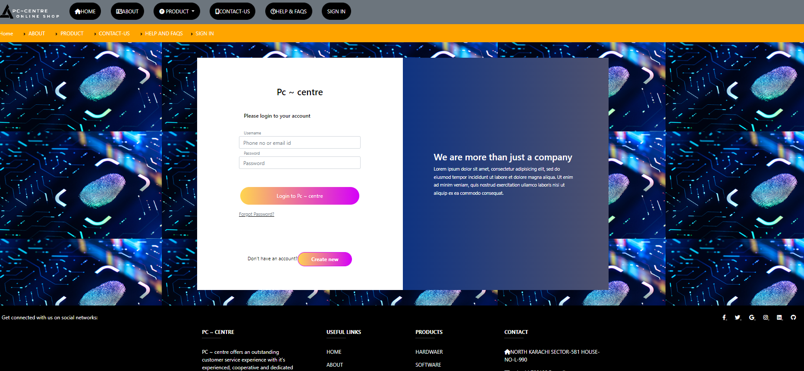

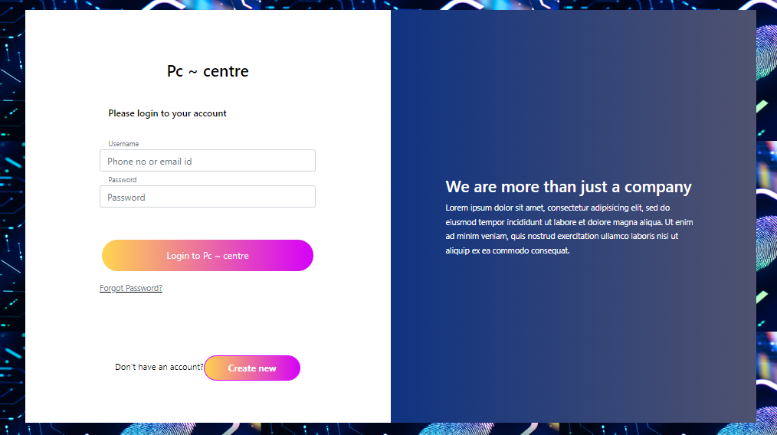

C) Help_faqs.html)

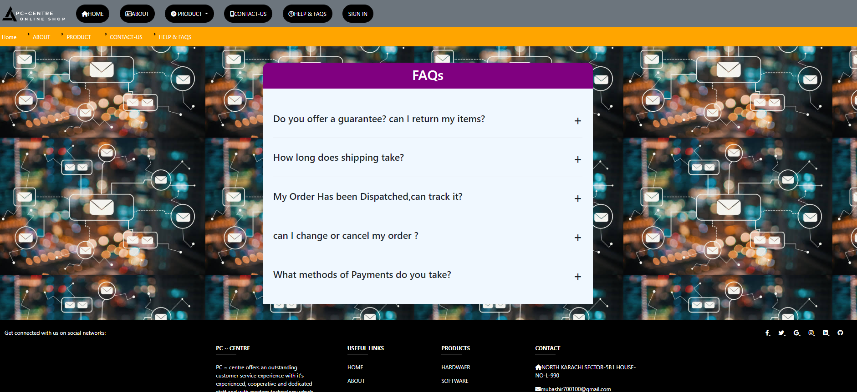

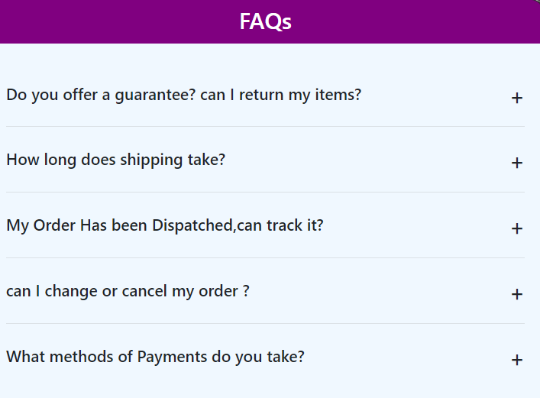





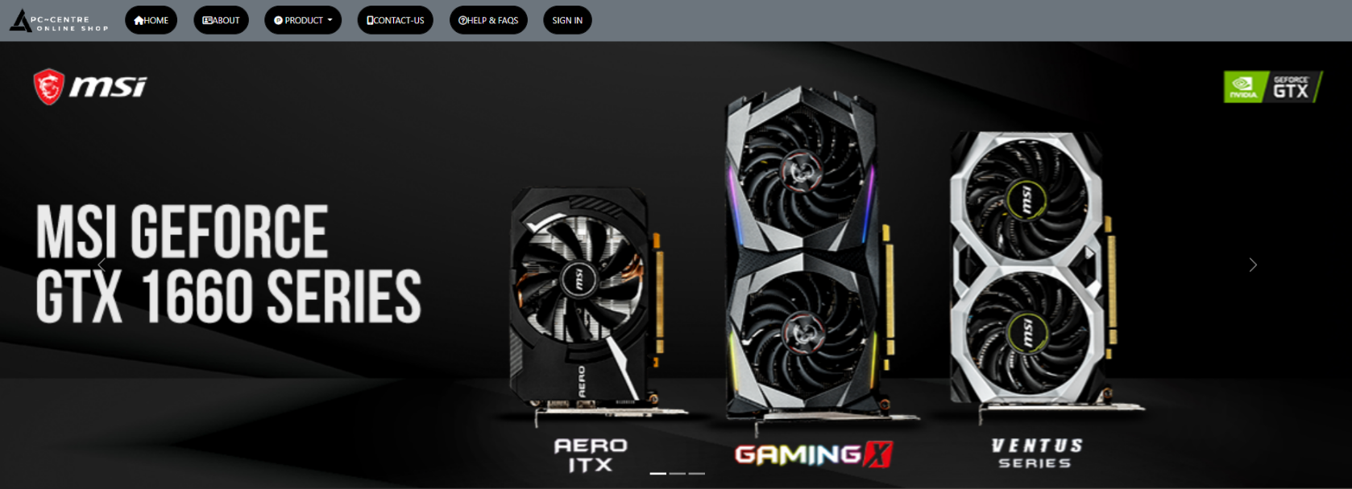

Gallery (Gallery.html)

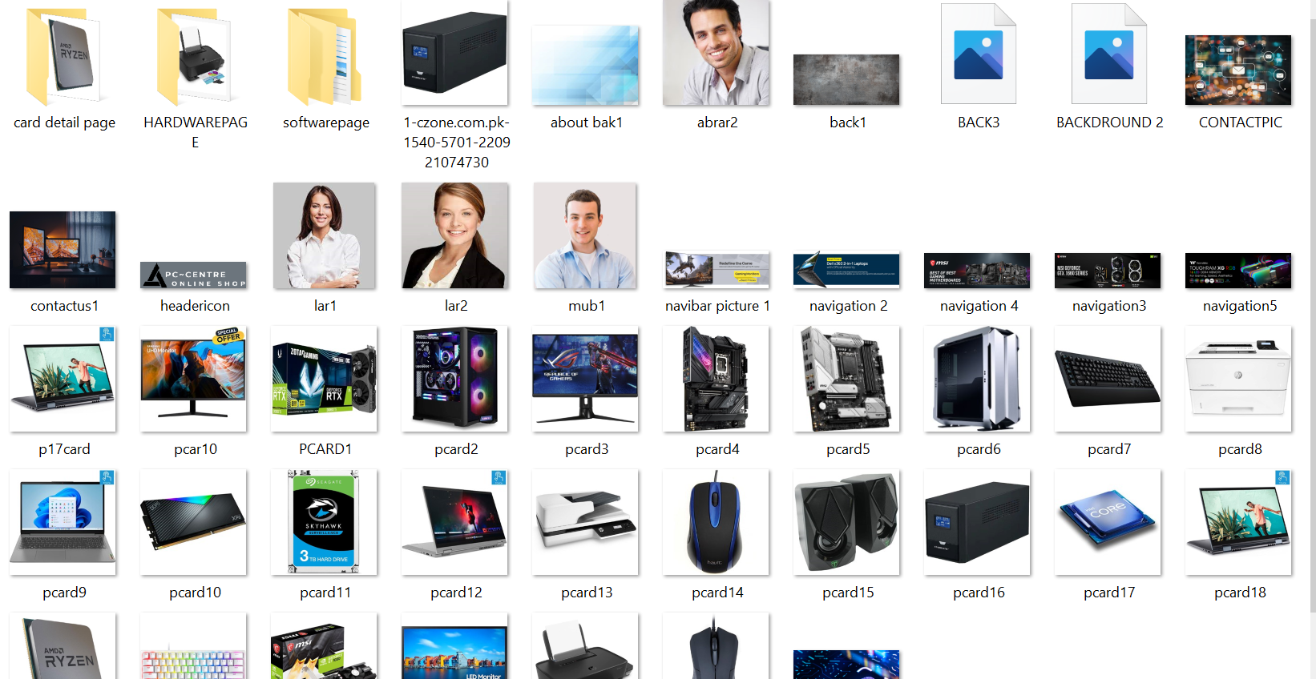

Login Page (Login.html)

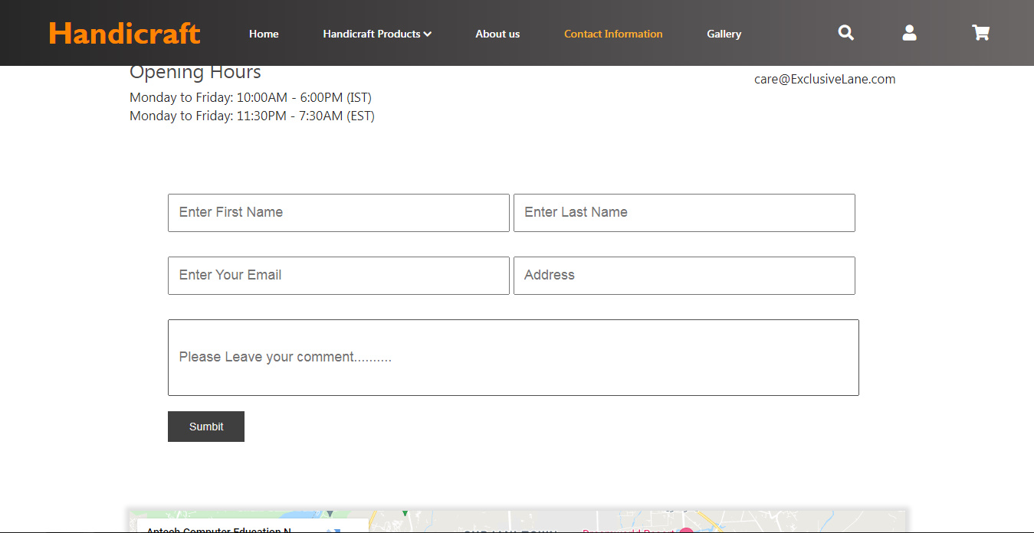

# TASK SHEET REVIEW 2

|  |  |  |  |  |  |  |
| --- | --- | --- | --- | --- | --- | --- |
| Project Ref. No.: eP/Advertisement Portal Management  System/01 | | Project title | Date of Preparation of Activity Plan | | | |
| No | Task | ***P***  ***-***  ***C***  ***C***  ***E***  ***N***  ***T***  ***R***  ***E*** | Actual | Actual | Team-mate | Status |
| Start Date | Days | Names |
|  | Build Home Page  Begin Code  JavaScript For The Home Page  Slider | 11/4/2022 | 1 | Muhammad Mubashir | Complete |
|  | Contact Information page | 11/4/2022 | 7 | Muhammad Abrar | Complete! |
|  | Contact Information Page | 12/4/2022 | 5 | Muhammad Abrar | Complete! |
| 1 |  | 14/4/2022 | 2 | Muhammad  Abrar | Complete |
| Contact Information Page  + Site Map + Contact Us Form |
| 2 | Product Pages for products cards | 18/4/2022 | 2 | Rafay | Complete |
| 3 | Product Pages for products cards | 21/4/2022 | 1 | Rafay | Complete |
|  |
|  |
| 4 | Product Pages | 22/4/2022 | 1 | RAFAY | Complete |
| 5 | Product Pages | 23/4/2022 | 1/2 | RAFAY | Complete |
| 6 | Product Pages | 25/4/2022 | 1/2 | RAFAY | Complete |
|  |
|  |
| 7 | Product Pages | 24/12/2021 | 1 | RAFAY | Complete |
|  |
|  |

|  |  |  |  |  |  |  |
| --- | --- | --- | --- | --- | --- | --- |
| 8 | Product Pages cards |  | 26/4/2022 | 1 | Muhammad  mubashir | Complete |
|  | About Us Page | 26/4/2022 | 3 | Muhammad Hassan tahir ali | Complete |
| 9 | Build About Us Page | 27/12/2021 | 1 | Muhammad ABRAR | Complete |
|  | Build Gallery Page |  | 28/4/2022 | 2 | Muhammad MUBASHIR | Complete |
|  | Build FAQs Page |  | 29/4/2022 | 3 | TAYYAB | Complete |
|  | Build Privacy & Policy Page |  | 30 /4/2022 | 3 | MUHAMMAD HASSAN TAHIR ALI | Complete |
|  | Build Terms & condition Page |  | 29/4/2022 | 3 | Muhammad  ABRAR | Complete |
|  | Products Detail Pages of Every Products |  | 31/4/2022 | 10 | Muhammad MUBASHIR | Complete |

# TASK SHEET REVIEW 3

|  |  |  |  |  |  |  |
| --- | --- | --- | --- | --- | --- | --- |
| Project Ref. No.: eP/Advertisement Portal Management  System/01 | | Project title | Date of Preparation of Activity Plan | | | |
| No | Task | **PC-CENTRE** | Actual | Actual | Team-mate | Status |
| Start Date | Days | Names |
|  | Check color |  |  |  |  |
| 1 | format, size,  JavaScript, | 2/5/2022 | 2 | Muhammad ABRAR | Complete |
|  | responsive in the |  |  |  |  |
|  | Home page |  |  |  |  |
|  | Check color |  |  |  |  |
| 2 | format, size,  JavaScript, responsive in | 4/5/2021 | 2 | Muhammad  MUBASHIR | Complete |
|  | Product page and |  |  |  |  |
|  | Product Line-up |  |  |  |  |
|  | Check color  format, size, JavaScript, |  |  | Muhammad  MUBASHIR |  |
| 3 | responsive in  About us, | 5/5/2022 | 3 |  | Complete |
|  | Contact Information, Gallery, |  |  |  |  |
|  | FAQs, Privacy & Policy, Terms & Conditions |  |  |  |  |
|  | page |  |  |  |  |
| 4 | Write a developer guide | 7/5/2022 | 1 | TAYYAB | Complete |
| 5 | Write user |
| manuals |  |  |  |  |
| 6 | Overall inspection of the | 9/5/2022 | 3 | Muhammad  MUBASHIR | Complete |
|  | project |  |  |  |

**Thank You**